
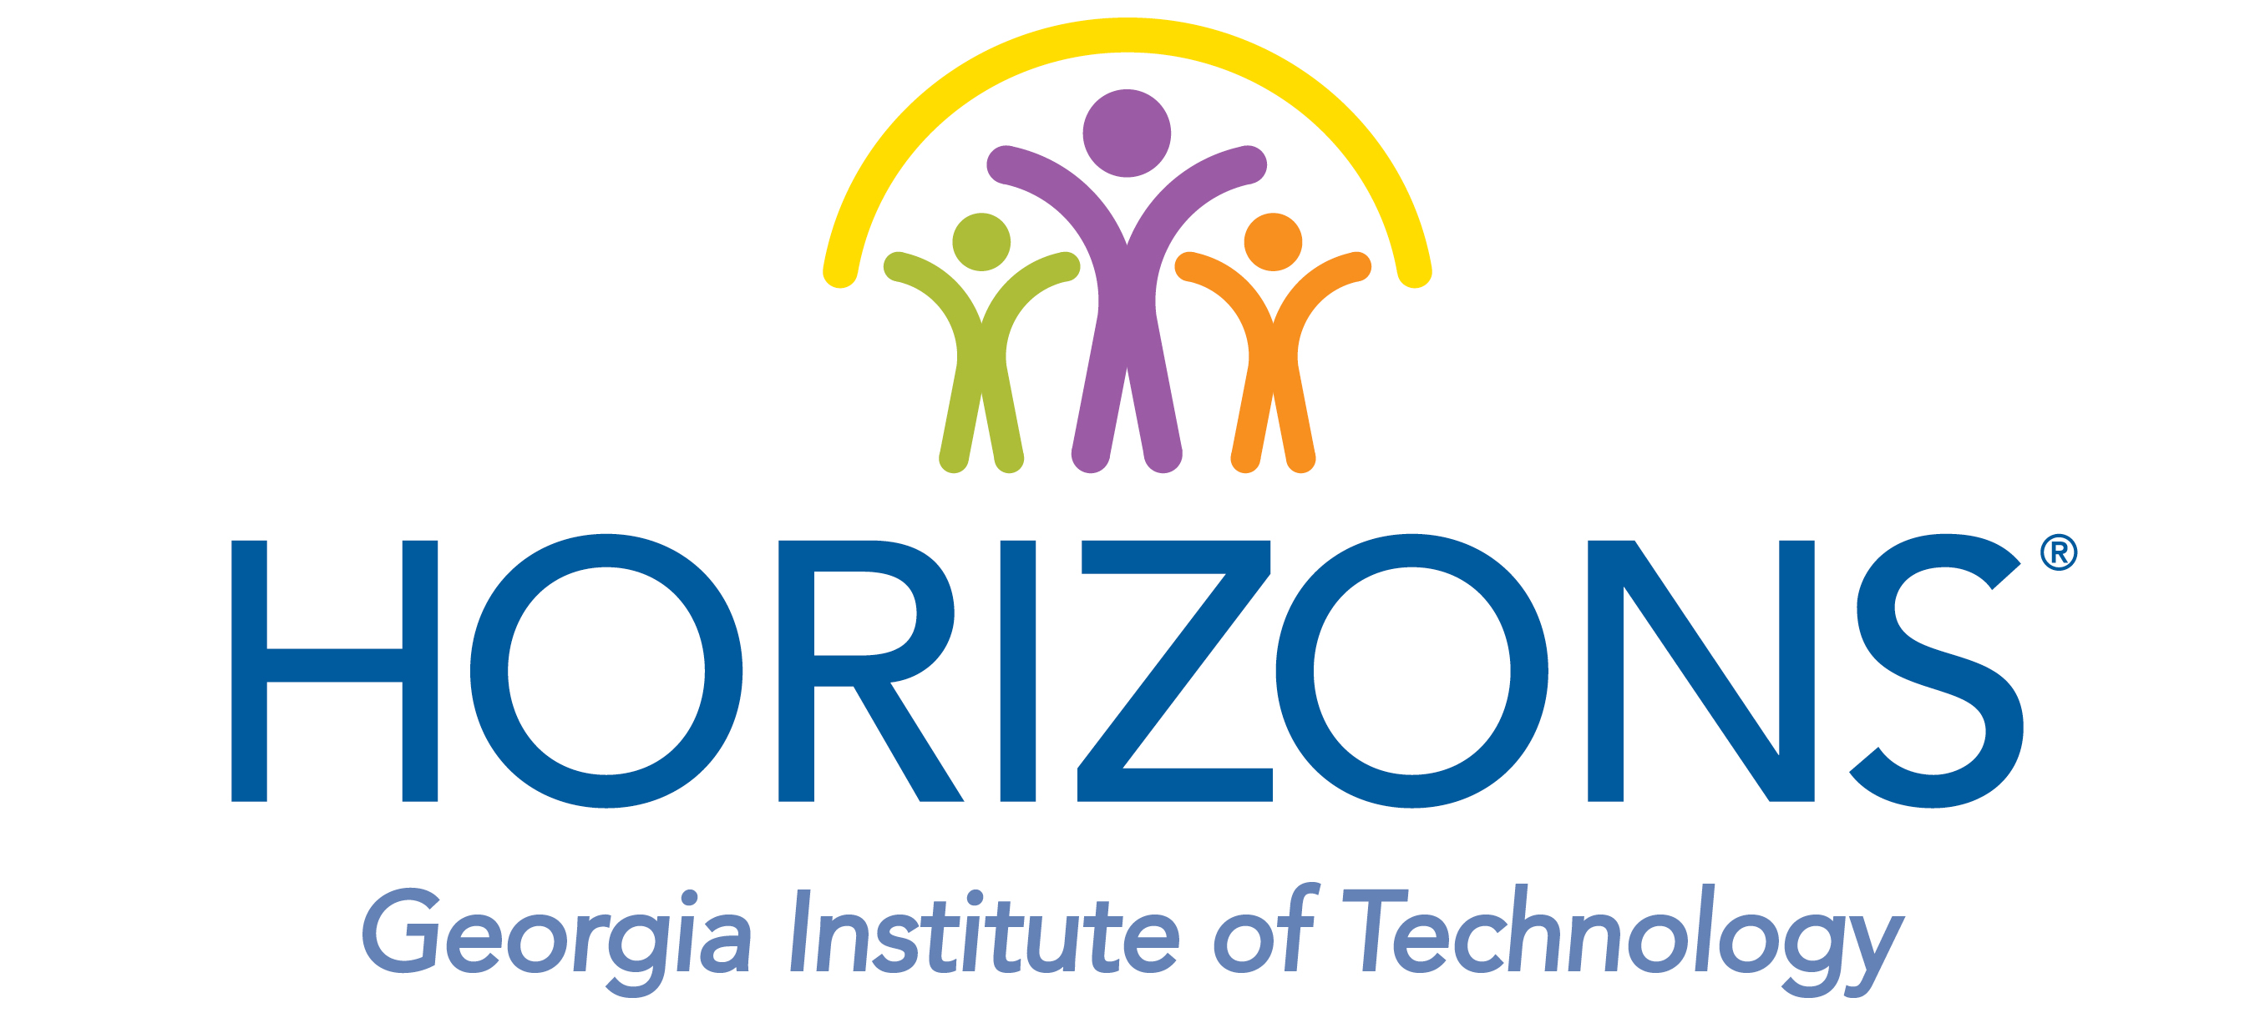

Horizons at Georgia Tech Assistant Teacher Internship

ELIGIBILTY:
• Current Georgia Tech Student in good academic standing
• Must be available for all six-weeks of the Summer Program, Staff Orientation, Planning & Class
Set-up
• Must be willing to actively participate with the students during their daily swim lessons
• Swimming ability not required but comfort in the pool is
• Must pass a criminal background and sexual predator check

Application deadline: March 30, 2018
Send application and resume to Sirocus Barnes, Program Director - sbarnes@horizonsatlanta.org

SUMMARY:
The Horizons at Georgia Tech Program is looking for talented and energetic individuals to work as Intern Assistant Teachers in a six-week academic enrichment Summer program. We are looking for professional, responsible, and caring individuals. Assistant Teachers work alongside certified lead teachers to implement strategies to engage students in active learning through non-traditional, hands-on activities in our six-week Summer program. Horizons Assistant Teachers work with approximately 15 students in small group and individual instruction in mathematics, reading, and science. A successful Assistant Teacher will enjoy working with youth and as a team player to help fulfill the Horizons mission.

A typical day may include academics, arts, swimming, breakfast/lunch and recreational activities. Teaching Assistants will also be responsible for bus monitoring, lunch monitoring, bus loading/drop off, and pick-up coordination as well as attending all field trips. Other duties may also be required.

TIME:
The program runs from Thursday, June 7th through Friday, July 13th and mandatory post planning on Monday, July 16th and Tuesday, July 17th. Mandatory orientation, planning and classroom set-up is scheduled for Wednesday, May 30th through Friday, June 1st and Monday, June 4th through Wednesday, June 6th. There will also be a mandatory Horizons Atlanta Regional Training on Saturday, April 21st.

PAY AND INTERNSHIP CREDIT:
Assistant Teacher positions qualify for six internship audit credit hours and transcript designation through Georgia Tech Pre-Teaching Advising if registered through the Georgia Tech Center for Career Discovery and Development. Interns do not pay tuition or fees for the audit credit hours. Horizons Georgia Tech provides the funding for the internships. Assistant Teachers earn $10 hour for 280 hours (total of $2800) for the entire program, including all trainings.

SECTION 1 - PERSONAL INFORMATION

Applicant’s Name: ______________________________________________________________

Home Address: _______________________________________________________________
City/State/Zip:________________________________________________________________

Date of Birth: _______________________ Phone: __________________________
Email: ______________________________________________________________________
Are you a United States Citizen or Permanent Resident? _____Yes _____No

Have you ever been convicted of an offense against the law or are you now under charges for any
offense? _____Yes ____No

If so, please explain:__________________________________________________________

Person to contact in case of emergency during the summer: ____________________________

Emergency Contact Phone: ____________________________

Emergency Contact Email: ____________________________

SECTION 2 - EXPERIENCE

Have you previously worked or volunteered in any Georgia Tech - CEISMC program?
If yes, please list program name(s), dates, and Program Coordinator(s):

_____

_____

Reason for leaving? ____________

List any talents, experience or certifications that you have that would be an asset to our organization.

_____

_____

_____

Have you ever worked/volunteered with disadvantaged or underserved populations?
___Yes ____No

If yes, when and what program? ___

____________

_____

_____

__________________________________________________________________________________________

SECTION 3 – EMPLOYMENT HISTORY

Name of Company:_______________________________ Position Held:________________________

Dates of Employment: ______________ Reason for Leaving:_________________________________

Supervisor Name: _____________________________ Contact Number: ________________________

Supervisor Email: ___________________________________May we contact them: ___Yes ____No

Duties:_______________________________________________________________________________

_____________________________________________________________________________________

Name of Company:_______________________________ Position Held:________________________

Dates of Employment: ______________ Reason for Leaving:_________________________________

Supervisor Name: _____________________________ Contact Number: ________________________

Supervisor Email: ___________________________________May we contact them: ___Yes ____No

Duties:_______________________________________________________________________________

_____________________________________________________________________________________

Name of Company:_______________________________ Position Held:________________________

Dates of Employment: ______________ Reason for Leaving:_________________________________

Supervisor Name: _____________________________ Contact Number: ________________________

Supervisor Email: ___________________________________May we contact them: ___Yes ____No

Duties:_______________________________________________________________________________

_____________________________________________________________________________________

SECTION 4 - REFERENCES

Please list 3 professional references not related to you, whom you have known at least for 1 year:

NAME PHONE EMAIL NATURE OF RELATIONSHIP

SECTION 5 – REQUIRED SIGNATURES

I attest that the information I have provided on this application is complete and accurate to the best of my knowledge. I also grant Georgia Tech - CEISMC permission to verify all information I provided with the appropriate offices and references.

Print Name: ____________

Signature: Date: ____________

What is Horizons Georgia Tech? Horizons Georgia Tech seeks to help children of limited financial means to find success in school and to set high goals for themselves including high school graduation and participation in post-secondary educational experiences. Horizons is committed to the development of the whole child through experiences that enhance confidence, foster awareness of community responsibility, build problem-solving skills, and encourage a life-long interest in learning. All Horizons students learn how to swim, making them safer and building confidence. We encourage children to take charge of their lives and realize their full potential. Come join our amazing program! For more information on Horizons at Georgia Tech please visit www.horizonsnational.org,
www.horizonsatlanta.org or www.ceismc.gatech.edu/horizons.

If you have any questions about Horizons at Georgia Tech, please feel free to contact:
Sirocus Barnes, MPA
Horizons Program Director
404-894-9707
sirocus.barnes@ceismc.gatech.edu

If you have any questions about internship credit hours, please feel free to contact:
Susan Belmonte, M.Ed.
Pre-Teaching Advisor
404-385-3494
sbelmonte@gatech.edu

