2015 Sculpture Classes
at Cherrylion Studios with Martin Dawe
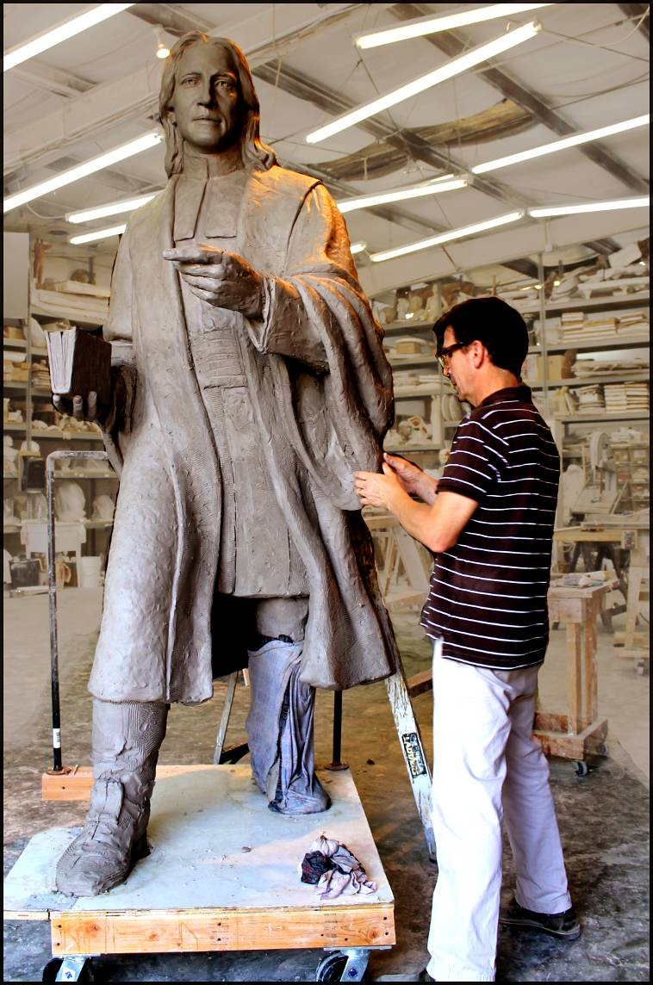
The classes are taught in a professional sculpture studio in a relaxed and creative atmosphere. A live model is provided in an open-studio format and instruction is given in clay sculpture techniques and proportion as students are taught how to ‘see’ three-dimensionally. Individualized instruction is unique to each student and all levels are welcome. Martin has 34 years of experience as a sculptor and is know for his numerous sculptures around Atlanta.

Winter 2015

Jan 13 – Mar 17
Tuesday 10am – 1pm
Tuesday 7pm - 10pm
Jan 15 – Mar 19
Thursday 7pm – 10pm

Spring
April 7 – June 9
Tuesday 10am – 1pm
Tuesday 7pm - 10pm
April 9 – June 11
Thursday 7pm – 10pm

Fall
Sept 8 – Nov 10
Tuesday 10am – 1pm
Tuesday 7pm - 10pm
Sept 10 – Nov 12
Thursday 7pm – 10pm

Each 10 week session is
$275
Tuition includes 25lbs of clay and firing
Credit cards accepted
Cherrylion Sculpture Studios
www.cherrylion.com
889 Morris St NW Atlanta GA 30318
404.350.4040
The studio is located off Howell Mill Rd ½ mile south of I - 75

